we will further restrict ourselves to only operating in the first “phrase” of sector 0 of Flash Block2:

Flash:

* FMC_PFB23CR
* Pg 771, do inputs to flash need to be bitwise inverted?
* FTFE_FCNFG PFLSH may need to be set to be set to 0
* RAMRDY?
* Flash commands pg 806
* Flash sector programming pg 827
* Command write sequence pg 811 “Before launching a command, the ACCERR and FPVIOL bits in the FSTAT register must be zero and the CCIF flag must read 1 to verify that any previous command has completed. If CCIF is zero, the previous command execution is still active, a new command write sequence cannot be started, and all writes to the FCCOB registers are ignored.”
* Load the FCCOB registers (can be written in any order) (There are multiple for multiple writings)
* Once all relevant command parameters have been loaded, the user launches the command by clearing the FSTAT[CCIF] bit by writing a '1' to it.
  + The FSTAT register contains a blocking mechanism, which prevents a new command from launching (can't clear CCIF) if the previous command resulted in an access error (FSTAT[ACCERR]=1) or a protection violation (FSTAT[FPVIOL]=1). In error scenarios, two writes to FSTAT are required to initiate the next command: the first write clears the error flags, the second write clears CCIF.
  + **May be relevant for error control**
  + ACCERR (error checker) is set when FCCOB registers are filled with invalid parameters
  + Also checks if that particular part of the flash is protected, if so FSTAT[FPVIOL] is set
  + Run-time errors are reported in the FSTAT[MGSTAT0] bit
  + Results are sent to FCCOB and FSTAT registers
  + The FTFE sets the FSTAT[CCIF] bit signifying that the command has completed.
* Not sure about FCCOB commands??
* Peter: To write to flash is an issue, (erase(back to 1), write), bulk erasure(can only be erased in blocks), EPROM) , memory is portioned, write8 needs to call write 16, tower is little endian by default but flash controller is big endian, create a data structure that mimics this address behaviour(byte reversed), write 1 to clear (w1c):Write in the mask where there is a 1 it will clear it,

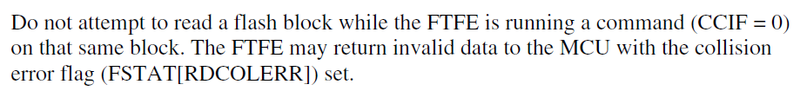

LED Pins for orange light: DONE

Clock things:

